FULL PAPER PREPARATION, PLEASE TYPE HERE THE TITLE

First Author1, Second Author2 and Third Author3
¹Mathematical Institute of the Serbian Academy of Sciences and Arts, 11000 Belgrade, Serbia
²Faculty of Mechanical Engineering, University of Belgrade, 11000 Belgrade, Serbia
³Similarly for all remaining co-authors
¹e-mail@organization.com; ²e-mail@organization.com; ³e-mail@organization.com

ABSTRACT (TIMES NEW ROMAN, 10pt.)
The Authors are kindly invited to prepare a full paper manuscript in MS Word file format. The manuscript should be 4 or 6 page long. Abstract should contain 250 words specifying the purpose, methodology, results and conclusion. (Times New Roman, 10pt.)
Please submit the full paper to the email address of the Conference: cfmsa@mi.sanu.ac.rs. The deadline for submission is February 20, 2025.
Keywords: keyword1, keyword2, keyword3, keyword4.

- INTRODUCTION (TIMES NEW ROMAN, 11pt.)
  - In the introduction, briefly specifying the purpose of the research and define the problem. (Times New Roman, 11pt)

- METHODOLOGY
  - Describe the methodology. (Times New Roman, 11pt.)
  - Subsection

- SECTION
  - Subsection
  - Subsection
Equations and formulae should be typed in MathType, and numbered consecutively with Arabic numerals in parentheses on the right hand side of the page (if referred to explicitly in the text).

$Q= 1 + 1\text{.}\text{464} {\left(\frac{b}{a}\right)}^{1\text{.}\text{65}}$ (1)

- RESULTS
  - The results should be described consistently and clearly. (Times New Roman, 11pt.)
  - Subsection
Tables should be with the corresponding consecutively number and explanations above them.

Table 1. Example (Times New Roman 10pt)
Results | Case 1 | Case 2 | Case 3 | Case 4
R1 | 3 | 1.2 | 4 | 5.9
R2 | 2.8 | 1.9 | 6.5 | 7,2
R3 | 2.3 | 2.3 | 8 | 7.9

Illustrations should be placed on the appropriate page, with the corresponding consecutively number and explanations under them (10 pt). All photographs, schemas, graphs and diagrams are to be referred to as figures.

Lettering and symbols should be clearly defined either in the caption or in a legend provided as part of the figure. Please ensure that all figures are of 300 DPI resolutions as this will facilitate good output.

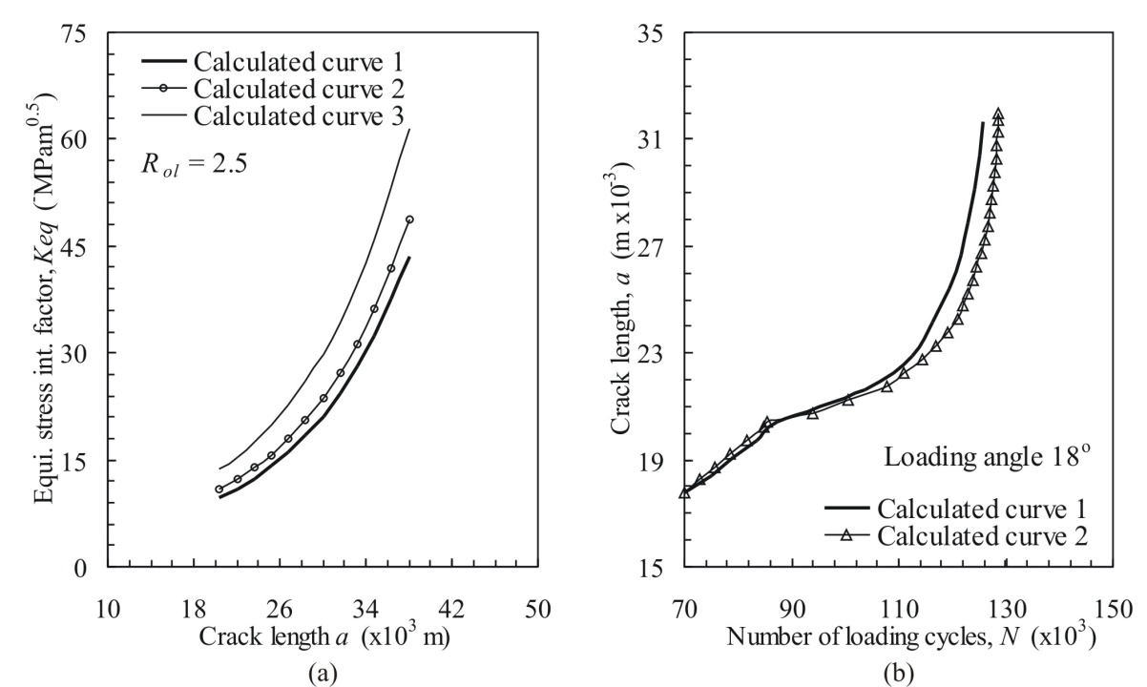
Fig. 2. (a) first diagram, (b) second diagram.

- CONCLUSIONS
Text (Times New Rman, 11pt.)

Acknowledgement
Text (Times New Roman, 10pt.)

Acknowledgement and References heading should be left justified, bold, as shown

References
- Fachinger, J, (2006), Behavior of HTR fuel elements in aquatic phases of repository host rock formations, Nuclear Engineering & Design, Vol. 236, No. 32, 54-6.
- Clark, T., Woodley, R., De Halas, D. (2011), Gas-Graphite Systems, in “Nuclear Graphite”, In: Nightingale, R. (Ed.) Academic Press, New York, 387-392.
- Deal, B., Grove, A. (2016), General relationship for the thermal oxidation of silicon, Journal of Applied Phisics, Vol. 36, 37–70.

